**Experiment No. 2**

**Aim:** To perform Discrete Auto/Cross Correlation between two signals

**Objective:**

1. Calculate correlation of a DT signals and verify the results using mathematical formulation. .

**Input Specifications:**

1. Length of first Signal L and signal values.

2. Length of second Signal M and signal values.

**Theory:**

**Correlation :** is a measure of similarity of two [waveforms](http://en.wikipedia.org/wiki/Waveforms) as a function of a time-lag applied to one of them. This is also known as a sliding dot or sliding inner-product. It is commonly used for searching a long signal for a shorter, known feature.

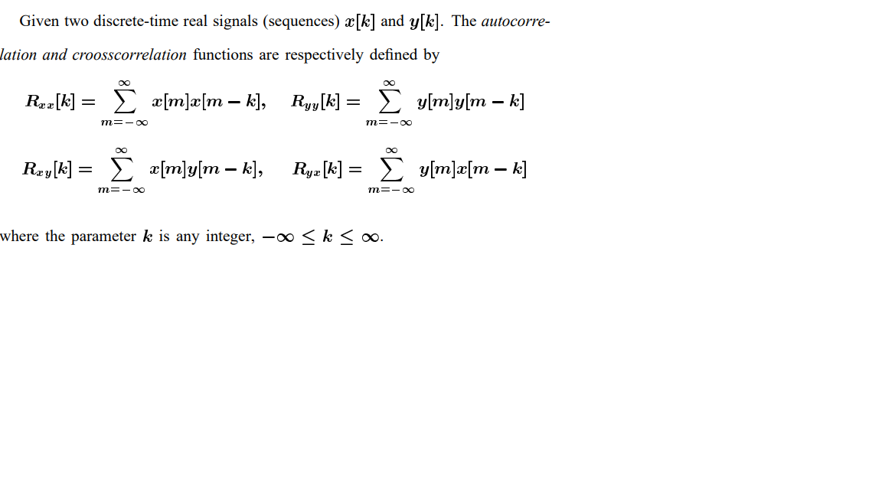

| **Problem Definition:**  1. Find auto correlation of delayed input signal.  2. Find cross correlation of input signal and delayed input signal,  3. Compare the resultant signals. Give your conclusion.  CODE:  % Correlation  x = input("Enter Fist Signal for Cross Correlation : ");  n = input("Enter Second Signal for Cross Correlation : ");  %x = [1 1 2 3]  %n = [2 1 1 2]  y = circshift(x,5);  [c,lags] = xcorr(x,y);  subplot(1,2,1),stem(lags,c);  title('Correlation');  % Autocorrelation  x = input("Enter Signal for Auto Correlation : ");  %x = [1 1 2 3 4]  [autoc,autolags] = xcorr(x);  subplot(1,2,2),stem(autolags,autoc);  title('Auto Correlation');  OUTPUT:  >> Correlation  Enter Fist Signal for Cross Correlation : [1 1 2 3]  Enter Second Signal for Cross Correlation : [2 1 1 4]  Enter Signal for Auto Correlation : [1 3 4 2 1]    **CONCLUSION:** We learnt about in build MATLAB functions for signal plotting and used them to implement Cross-Correlation and Auto Correlation.    **NAME: Junaid Girkar**  **SAP ID: 60004190057**  **BATCH: A2**  **Experiment No. 3**  **Aim:** To perform Discrete Convolution ( Linear and Circular)  **Objective:**  1. Calculate Linear Convolution, Circular Convolution & verify the results using mathematical formulation.  **Input Specifications:**  1. Length of first Signal L and signal values.  2. Length of second Signal M and signal values.  **Theory:**  **Convolution**  The Discrete-Time Convolution (DTC) is one of the most important operations in a discrete-time signal analysis. The operation relates the output sequence y(n) of a linear-time invariant (LTI) system, with the input sequence x(n) and the unit sample sequence h(n)    Circular convolution, also known as cyclic convolution, is a special case of periodic convolution, which is **the convolution of two periodic functions that have the same period**.    **Problem Definition:**  1. Find Linear Convolution and Circular Convolution of L point sequence x[n] and M point sequence h[n].  **CODE:**  a = input("Enter First Signal for Linear Convolution: ");%[1 2 3 -3 0 -1 4]  b = input("Enter Second Signal for Linear Convolution: ");%[1 2 3 1]  circular_a = input("Enter First Signal for Circular Convolution: ");%[1 -2 3 1]  circular_b = input("Enter Second Signal for Circular Convolution: ");%[1 4 2 3]  cref = conv(a,b)  subplot(2,1,1)  stem(cref,'filled')  title('Linear Convolution of x and y')  c = cconv(circular_a, circular_b,4)  subplot(2,1,2)  stem(c,'filled')  title('Circular Convolution of x and y')  OUTPUT:  >> LinearNCircularConvolution  Enter First Signal for Linear Convolution: [1 2 3 4 1 3 2 5]  Enter Second Signal for Linear Convolution: [1 2 5 2]  Enter First Signal for Circular Convolution: [1 3 5 2]  Enter Second Signal for Circular Convolution: [3 1 2 3]  cref = 1 4 12 22 28 31 21 26 26 29 10  c = 24 29 26 20 |  |
| --- | --- |
|  |  |

**CONCLUSION:** We learnt about in build MATLAB functions for signal plotting and used them to implement Linear and Circular Convolution.

**NAME: Junaid Girkar**

**SAP ID : 60004190057**

**BATCH: A2**